Histogram- A Histogram is a graphical display of data using bars of different heights. It is similar to a Bar Chart, but a histogram groups numbers into ranges. And you decide what ranges to use! Histograms are a great way to show results of continuous data, such as: weight, height, how much time, etc. But when the data is in categories (such as Country or Favorite Movie) we should use a Bar chart.
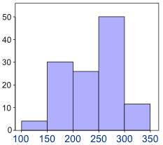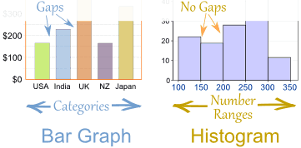
The histogram to the left, displays the number of orange trees at different heights. For example, there are 30 trees between the heights of 150 cm to 200 cm.

Box Plot- A graphical display of data where the data is divided into to four quartiles where each quartile represents 25% of the data.
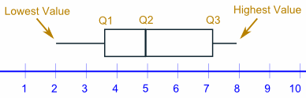

Dot Plot- a graphical display of data using dots. A survey of "How long does it take you to eat breakfast?" had the following results:
Minutes | 0 | 1 | 2 | 3 | 4 | 5 | 6 | 7 | 8 | 9 | 10 | 11 | 12
People | 6 | 2 | 3 | 5 | 2 | 5 | 0 | 0 | 2 | 3 | 7 | 4 | 1
Which means that 6 people take 0 minutes to eat breakfast (they probably had no breakfast!), 2 people say they only spend 1 minute having breakfast, etc. And here is the dot plot:
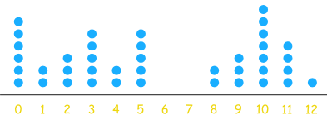
Frequency Table | Relative Frequency Table
Values and their frequency (How often each value occurs).  Example: These are the numbers of newspapers sold at a local shop over the last 10 days:  22, 20, 18, 23, 20, 25, 22, 20, 18, 20  We can count the frequency of each one. So there are 2 stores who sold “18.” There are 4 stores who sold “20”. It is also possible to group the values. Here they are grouped in 5s:  Paper Sold 15-19 20-24 25-29  Frequency 2 7 1 | How often something happens divided by all outcomes.  Example:  We asked a class what type of music they liked and 19 said pop, 12 said Rock n Roll, 6 Hip Hop, and 4 other.  Items Frequency Relative Freq.  Pop Music 19 19/41 = 46%  Rock n Roll 12 12/41 = 29 %  Hip Hop/Rap 6 6/41 = 15 %  Other 4 4/41 = 10 %  Total 41 100%

