~Shape~
Normal/Mound Shape | Skewed Right | Skewed Left | Outliers | Clusters
Approximately normal/ Mound shape- distribution has one peak and tapers off on both sides.  Normal- symmetric;  Points are evenly distributed among a central value or location.  The median, mode, and mean are all close to the same value.  -The mean is used to describe the central location of distribution.  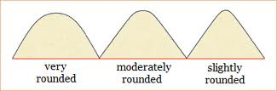 | Skewed to the right or skewed to the larger values  *the "skew" is in the direction of the long tail  -The measure of central location is the median.  .  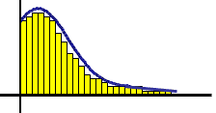 | Skewed to the left or skewed to the smaller values  *the "skew" is in the direction of the long tail.  -The measure of central location is the median.  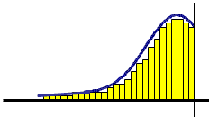 | Outliers- unusually large or small values that fall outside the overall pattern.  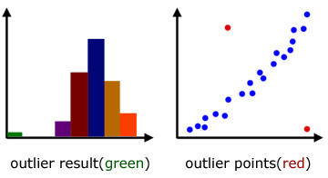 | Clusters- groups of data separated by gaps  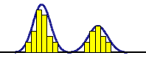

Summary Statistics
Center | Spread
Where is the center of the data? The measure of center you are most familiar with is mean or average. However, depending on the shape of the data, the center might be measured with the median instead.  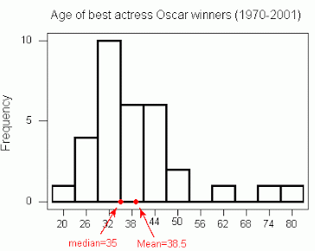 | What is spread? Exactly how it sounds- how spread out is the data. We measure the spread with the range, interquartile range and standard deviation.  